UNICEF ASSESSMENT OUTPUT

Author X

2025-07-28

# Introduction

This is my submission for the Household Survey Data Analyst Consultant - Req. (581656) position. Below, is my output and brief analysis.

# Figure 1

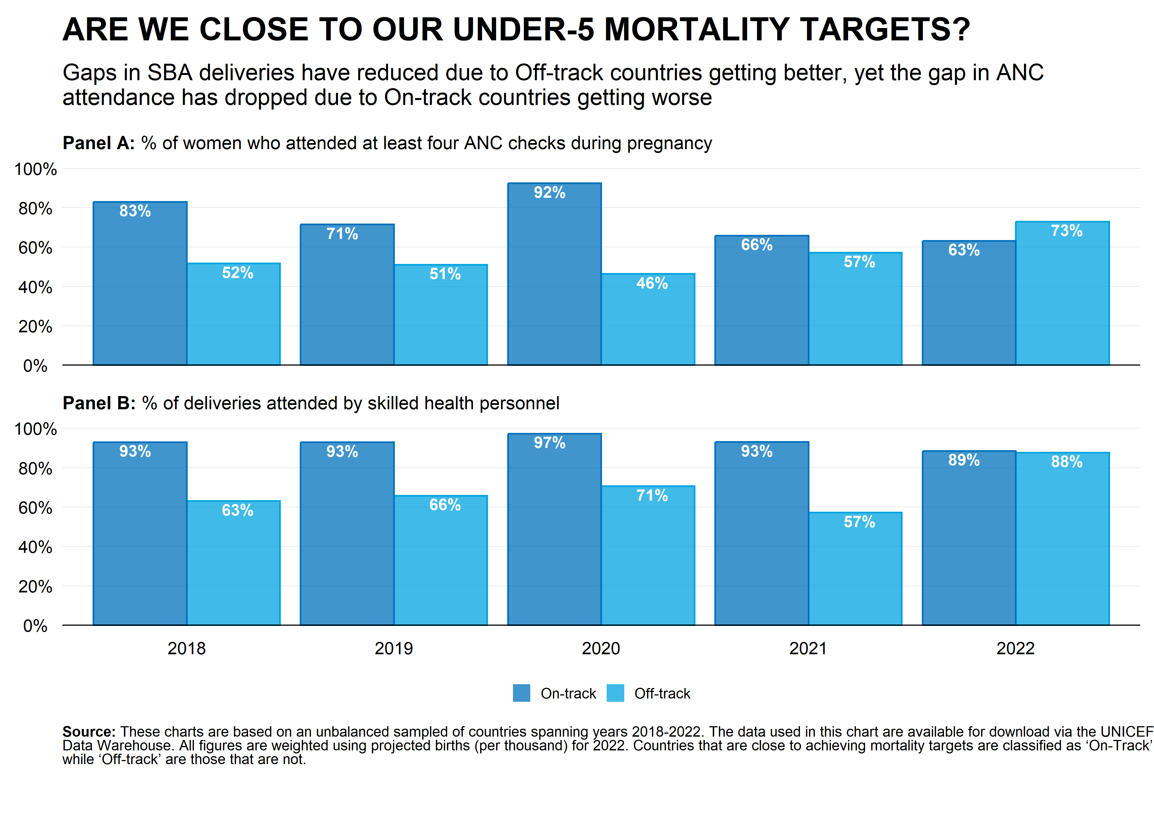

# Analysis

Panel A of figure 1 suggests that there has been some measure of convergence between Off and On-track countries with regard to safe deliveries - the safe-delivery gap between these countries comes down from 30 percentage points in 2018 to ~1 percentage point in 2022. However, Panel B, tells a slightly different story - the gap between On/Off-track countries in 2018 was ~30 percentage points. In 2022, Off-track countries are actually 10 percentage points higher - however,the reversal of the gap between these countries seems to be driven by a ~20 percentage point *decrease* in the probability of women in countries classified as On-track getting at least 4 ANC check-ups, rather than a one-way *increase* in probablity of recieving these ANCs checks for women in Off-Track countries.

## Assumptions and Caveats

This analysis makes the following assumptions - firstly, there is a compositional change in the the sample - between 2018 and 2022, the number of countries included in the sample, decreases by more than 50% - this could be due to the fact that the COVID-19 pandemic may have delayed surveys in many countries, and as such recent data is not available for all countries. For the sake of this analysis, we make assume (indeed, this is a big assumption) that selection into the 2022 sample, is uncorrelated with our outcome of interest.

Second, there is also a small set of countries for whom the names do not match exactly (this is the case for the ISO code as well - one such example, is Kosovo (which is spelt differently across multiple datasets). In the interest of time, I did not make any attempt to clean these names.